**Database Management System – 19CSE202**

**Lab Assignment – 2**

S. ABHISHEK

AM. EN. U4 CSE19147

**Create the tables with suitable constraints:**

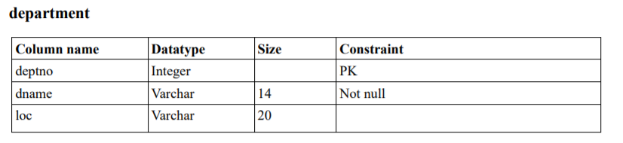

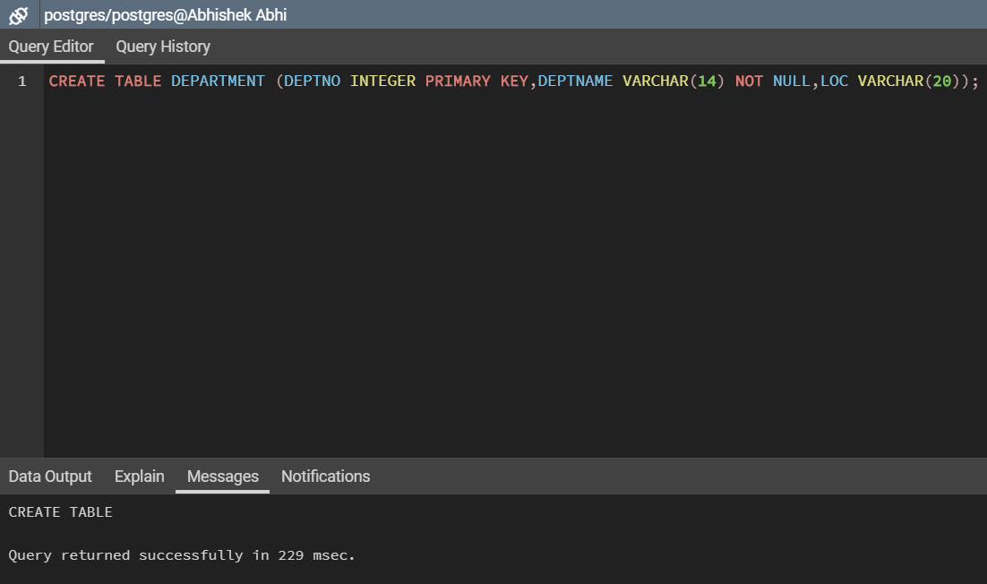

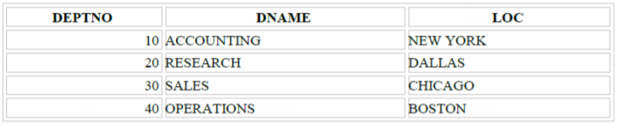

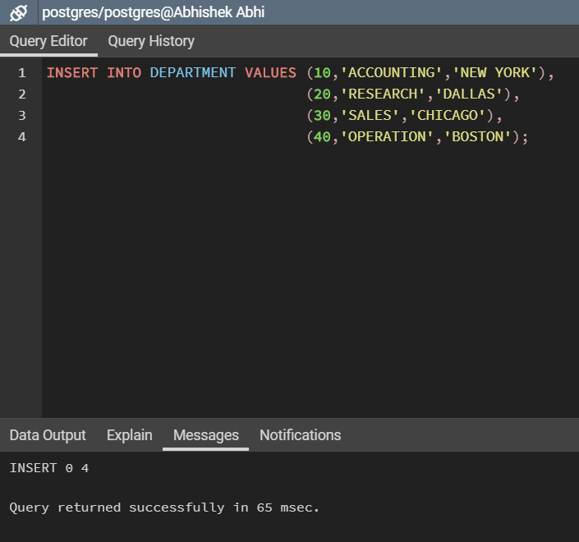

**Insert data in the two tables:**

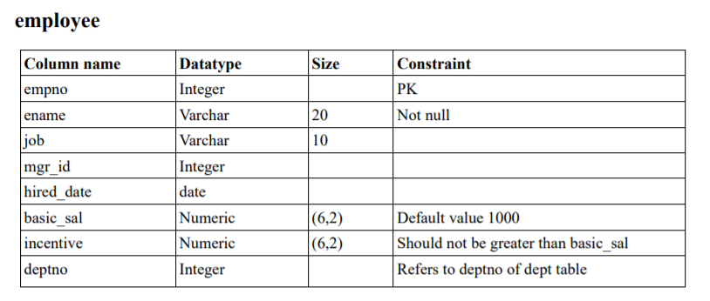

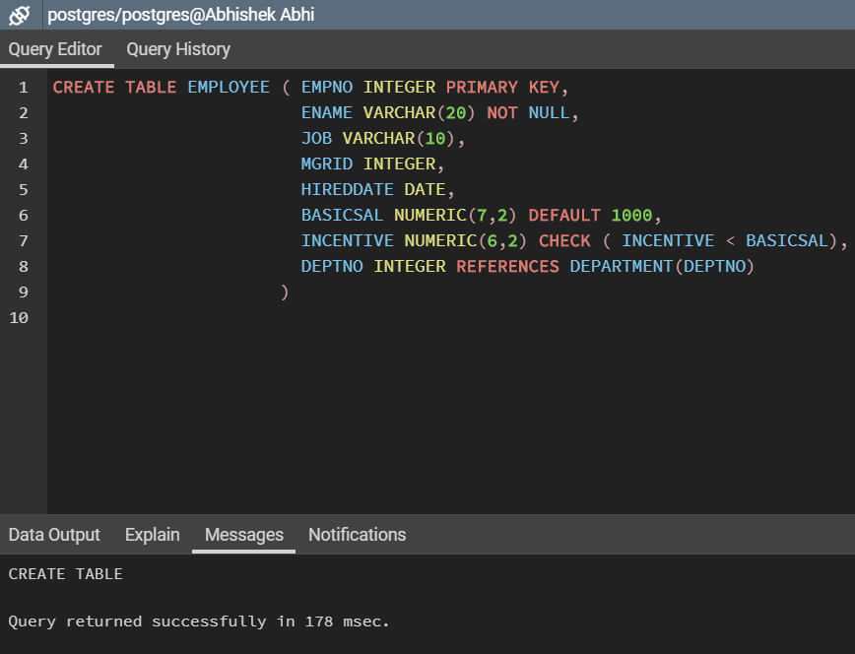

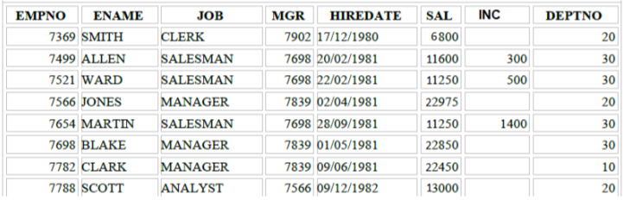

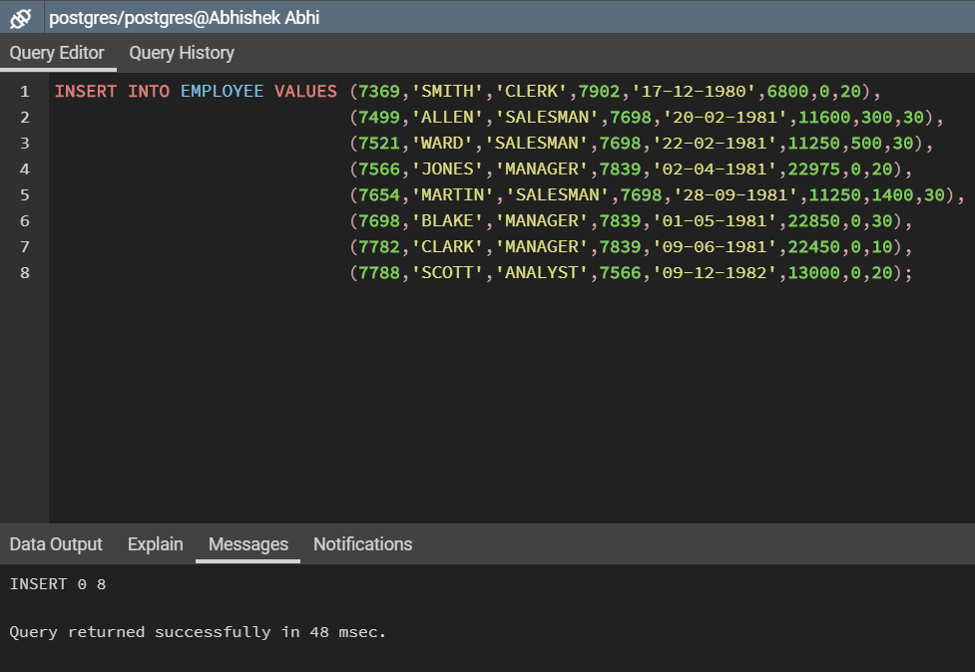

**Select all data from the DEPARTMENT table:**

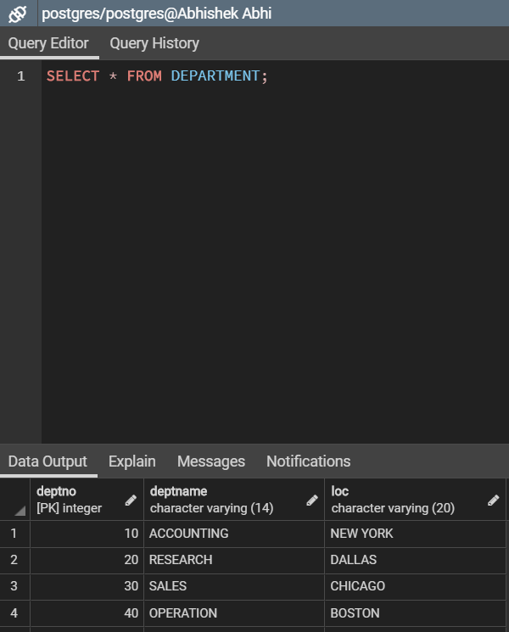

**Get the details of all the employees:**

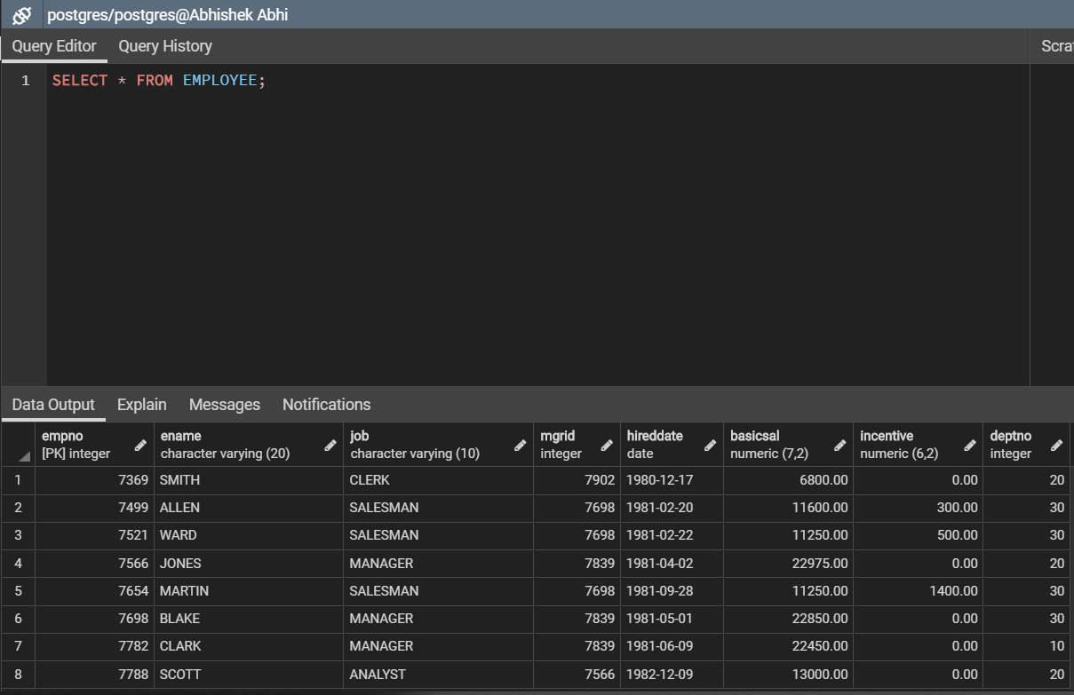

**Show the details of employee ‘BLAKE’:**

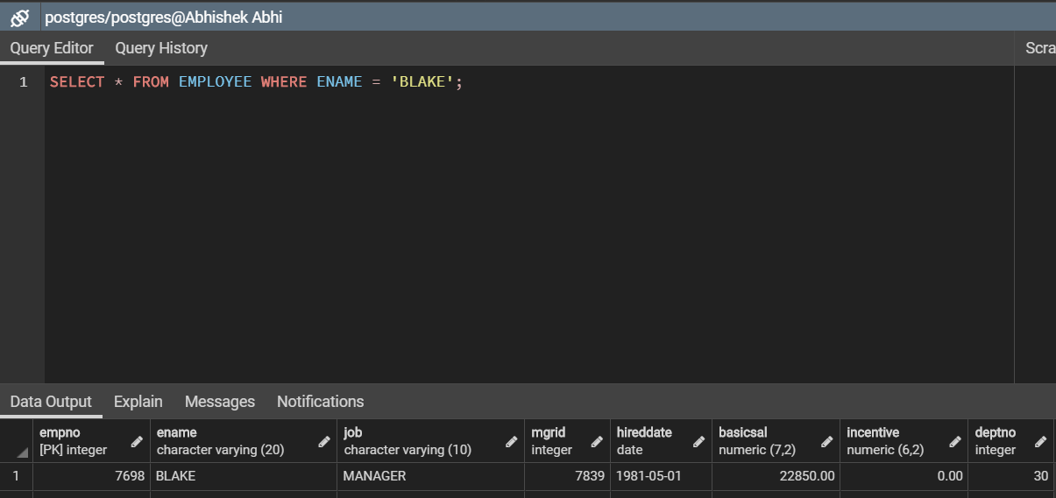

Get employee number, employee name of employees who are managers:

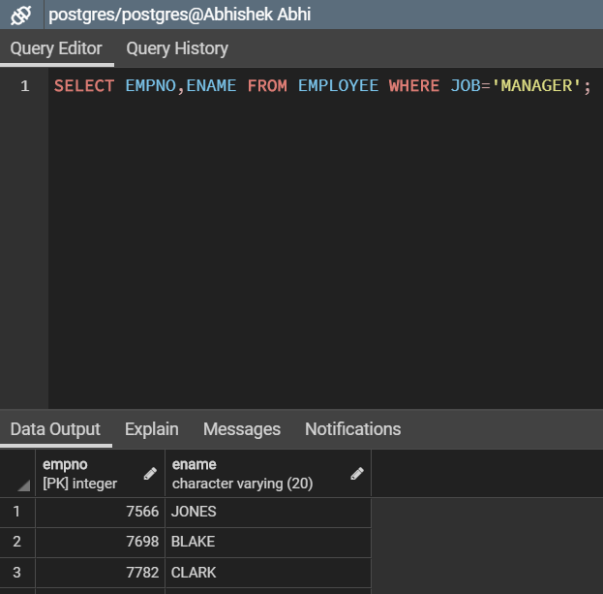

**Display unique jobs with second letter as ‘a' from the EMPLOYEE table:**

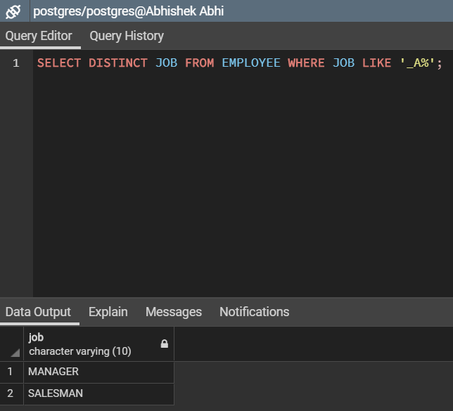

**Display the names of employees concatenated with their jobs:**

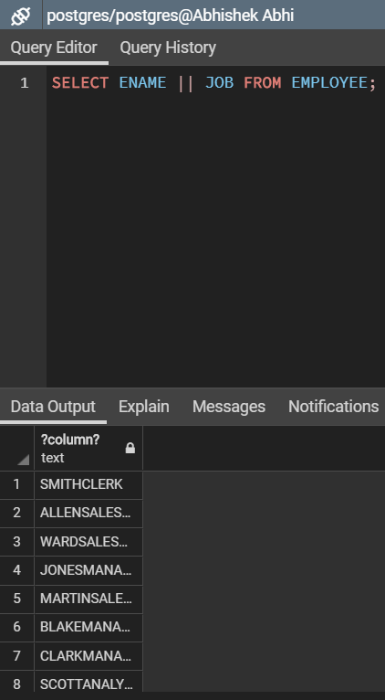

**Display all the names, department numbers and hired dates from the EMPLOYEE table:**

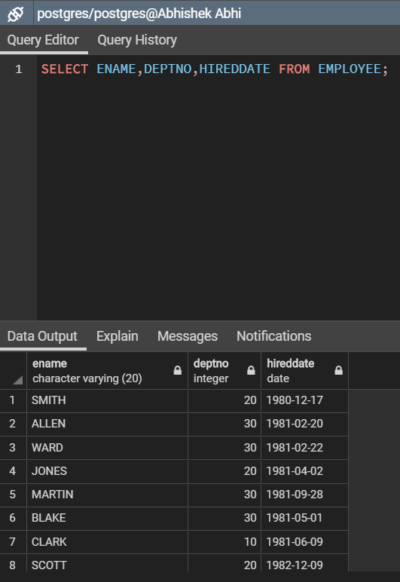

**Display employees in the ascending order of their names:**

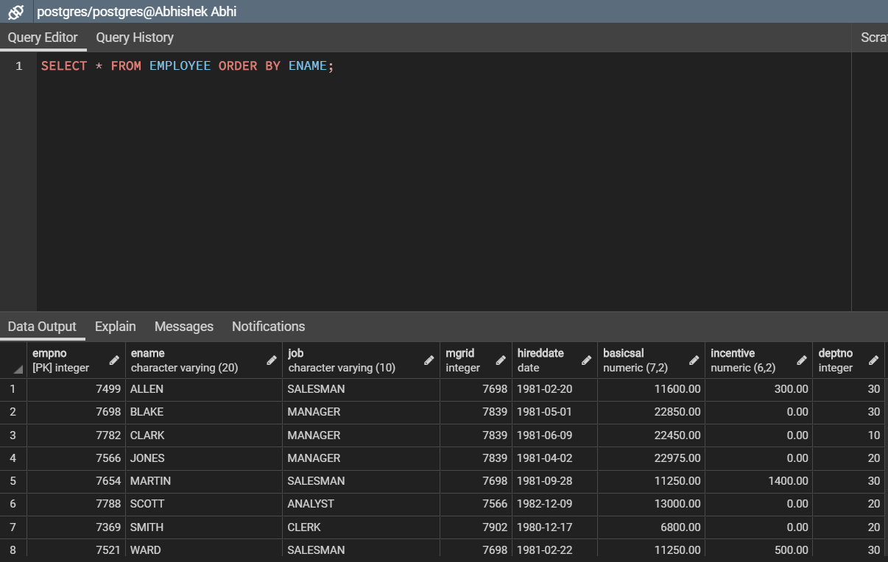

**Find the names of all employees that begin with ‘S’ or ‘J’:**

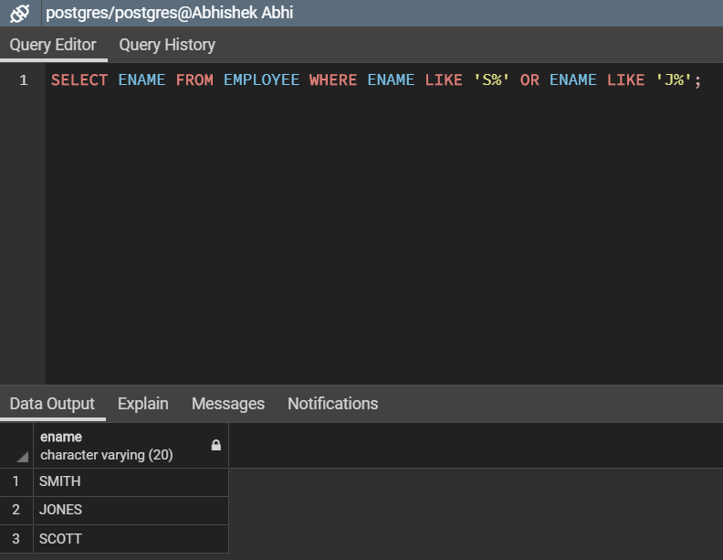

**Get the highest salary from the EMPLOYEE table:**

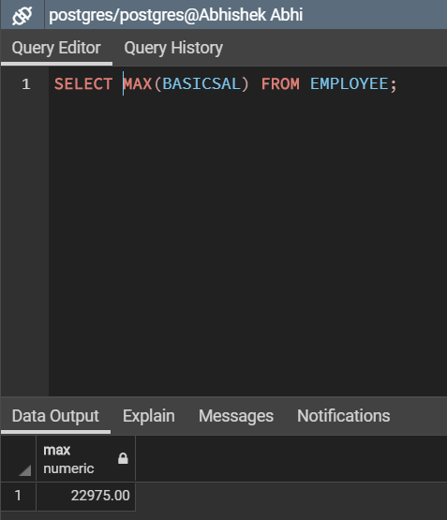

**Display the names, deptno of all employees who receive salary between 10000 and 25000:**

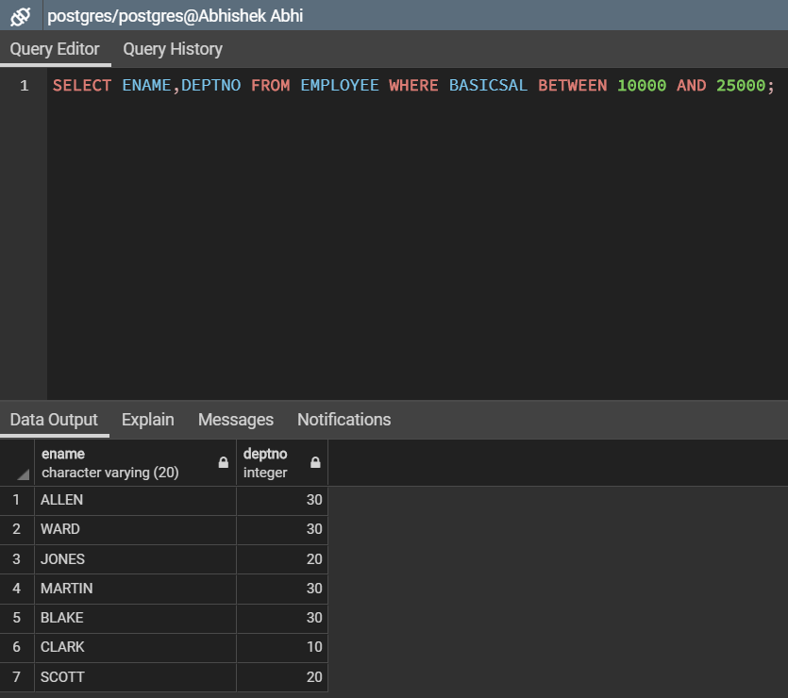

**List department number and count of employees in each department ordered by department number:**

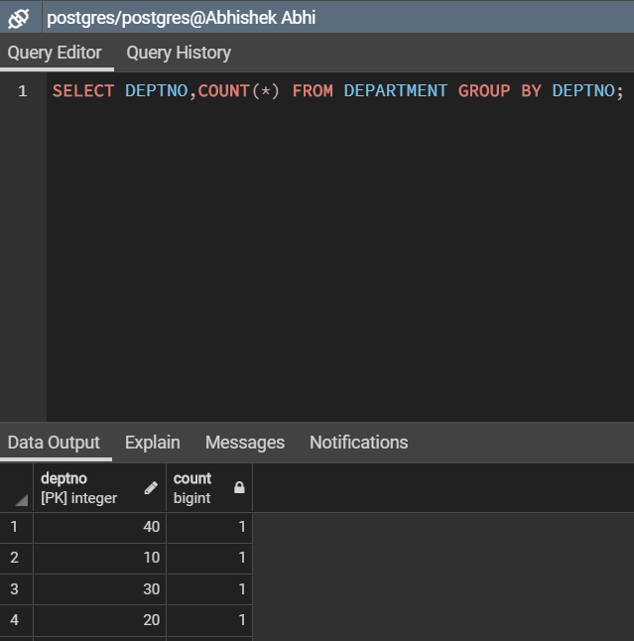

**List the names and hired date of managers and clerks without incentives:**

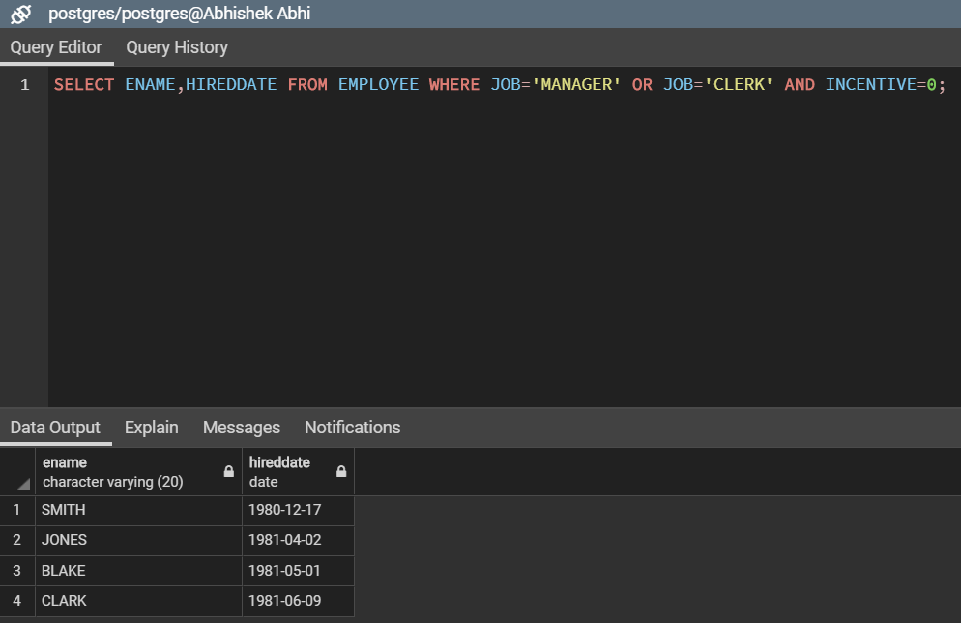

**Delete the records with deptno '10' from the EMPLOYEE table:**

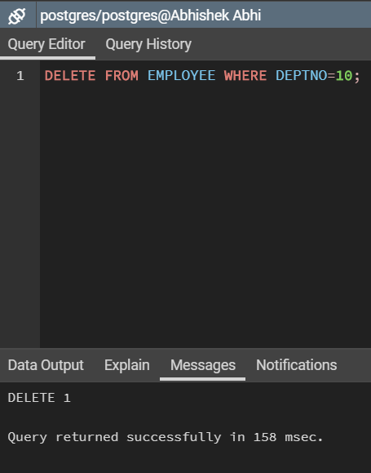

**Print the names and jobs of all employees except ‘analyst’:**

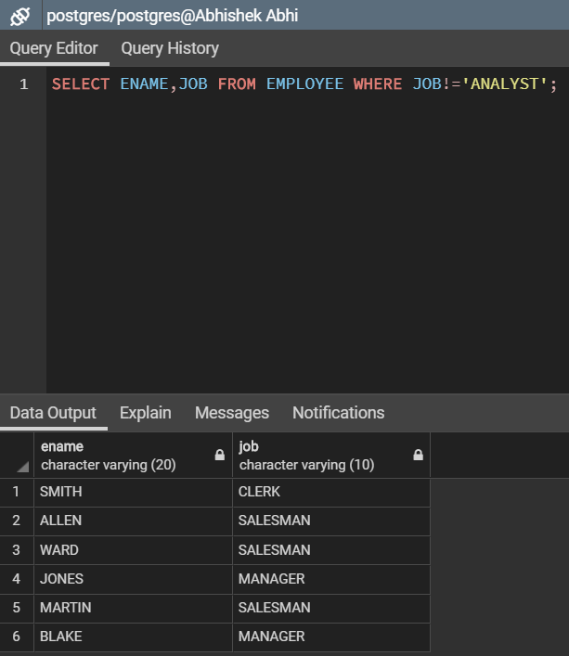

**Print the name of employees whose salaries are greater than the value 21000:**

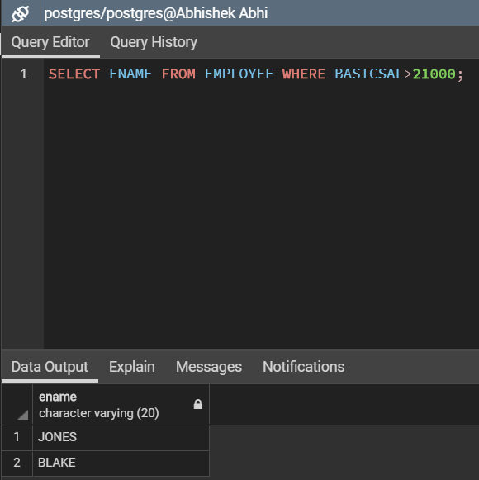

. **Find the names of employees who have a salary equal to Rs 13000:**

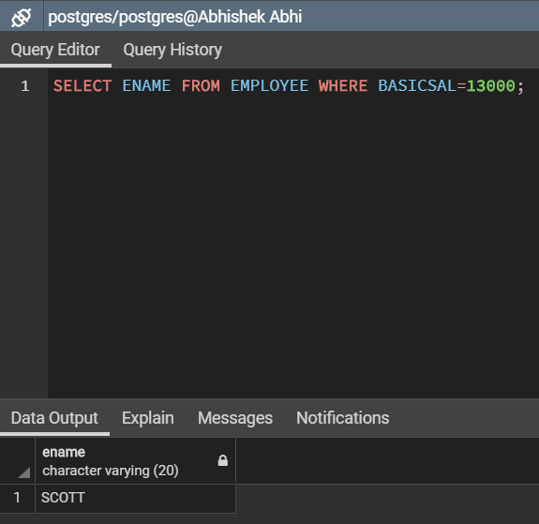

**Display the empname, deptno, hired date information in the dept '20' and '30':**

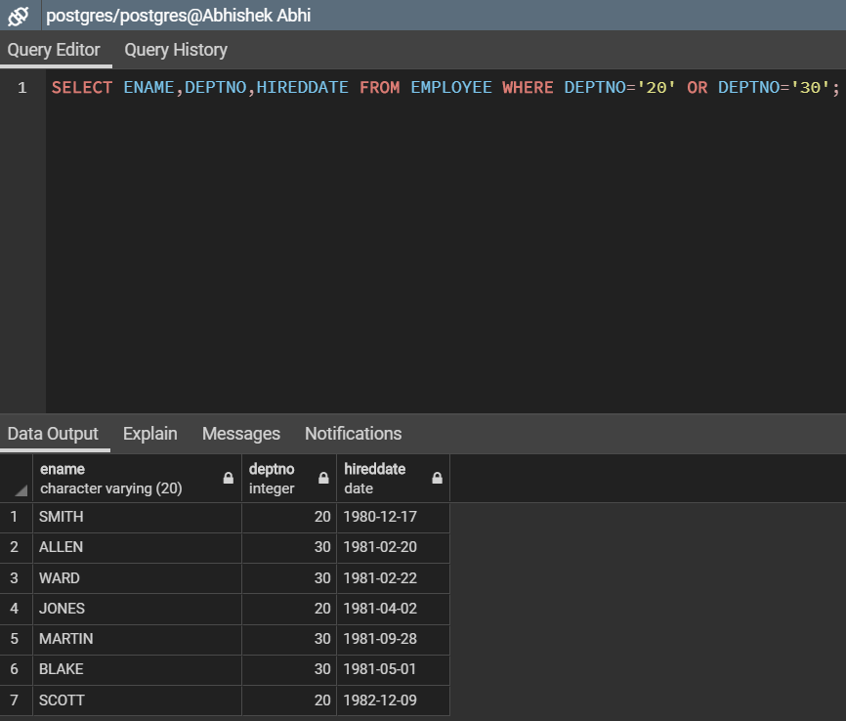

**!! THANKYOU !!**